Why I chose Microsoft Visual Studio Code

A text editor is an application where you can write your code and, if possible, commit the changes to your repository. There are a few options for programmers, such as Microsoft Visual Studio Code, Sublime Text, and Notepad++. For myself, I have chosen Microsoft Visual Studio Code because not only is it easy to navigate and has a variety of extensions, but it also integrates with GitHub. Throughout this blog entry, I will take you through Microsoft Visual Studio Code and advise why this should be your code editor of choice.
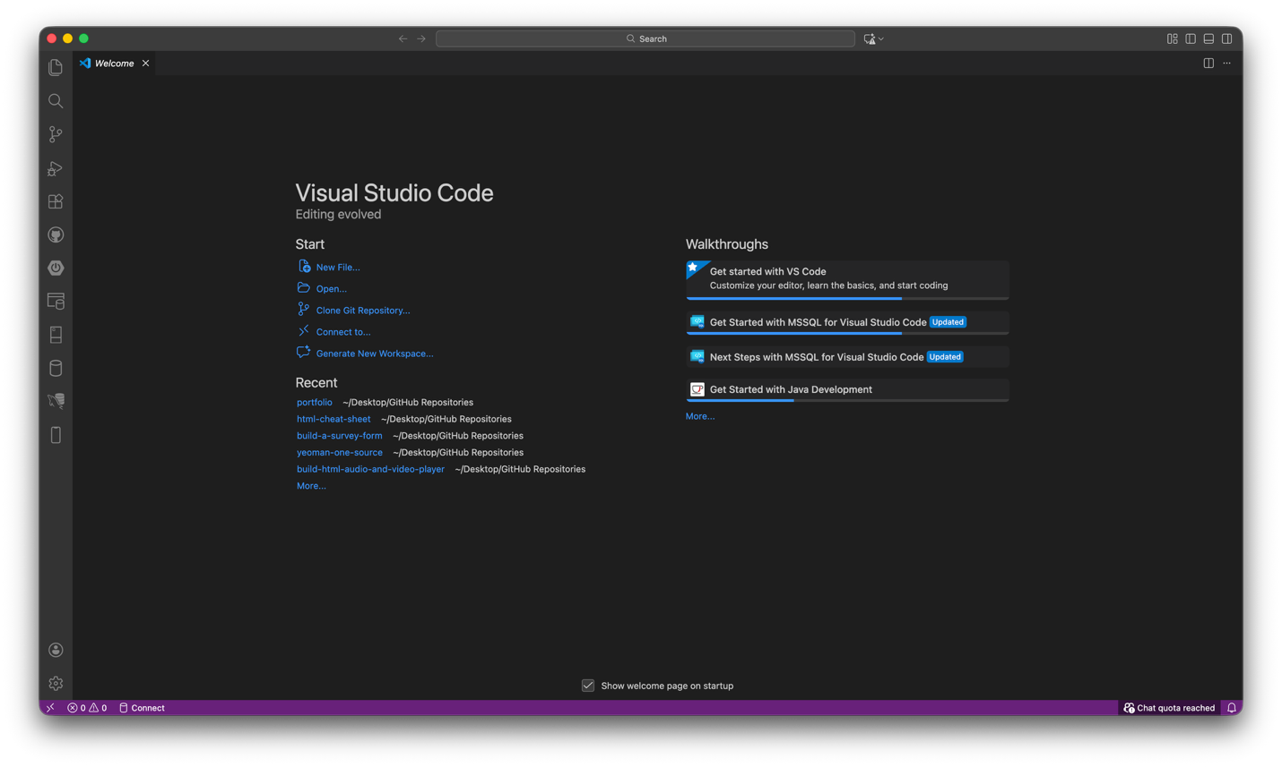
When you download Visual Studio Code, this is the typical homepage that you will see. From here, you can create a new file, open the current file, and Clone a Git Repository. If you have a GitHub account (which you should), if you click on the gear icon in the lower left, you then can navigate and sign in to your GitHub account. Once signed in, you can clone a repository for easy access.
Note: Create a folder on your desktop and label it “GitHub Repositories”. This will be the central location where you will clone your repositories.
On the left side of the application, you will see buttons and extensions that you can add for easy access. The main buttons starting on the top are Explorer, Search, Source Control, Run and Debug, and Extensions. As you download additional extensions such as GitHub and Spring Boot Dashboard, they will be installed on the left side. It is highly recommended that, as a beginner programmer, you only download extensions that you need, so you don’t get overwhelmed. If you find that you downloaded an extension, but don’t use it, uninstall it.

